INSTRUCTIONS AND PREPARATION FOR ANORECTAL MANOMETRY
Anorectal manometry is a test done in clinic that allows the GI Motility specialist to evaluate anal sphincter function. A catheter is inserted into the rectum and a small balloon at the end of the catheter will be inflated to simulate stool. Pressure readings are measured that allow the physician to evaluate nerve and muscle function. During the procedure, your child may be asked to participate and perform activities such as pushing and squeezing. The procedure is not painful, but many children are anxious about the intervention. The primary discomfort experienced during the procedure may be mild discomfort when the catheter is being inserted. There will be a Child Life Specialist available to help with distraction for your child if needed. The test should last 15-20 minutes.

- On the morning of your child’s clinic appointment: Your child will need to do a Fleet Saline Enema, this can be done approximately an hour prior to leaving for your appointment to allow enough toilet sitting time.
  - If your child is 11 years old or older, then they will need to do an ADULT Fleet’s saline enema
  - If your child is 10 years old or younger, then they will need to do a PEDIATRIC Fleet’s enema
  - Enemas can be found at your local grocery store (usually near the pharmacy) or drug store. Below are some examples of what to look for:
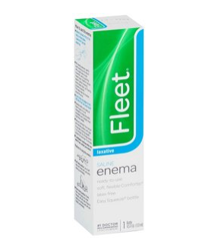

Pediatric Enema-> child < 10
DO NOT USE

Pediatric Saline Enema-> Child is <10

DO NOT USE
- If you are unable to locate a pediatric enema, you can administer half of an adult enema
- If you have any questions or concerns, please contact the motility clinic at 801-662-1619

