Introduction to Insulin Pumps Classes 2021

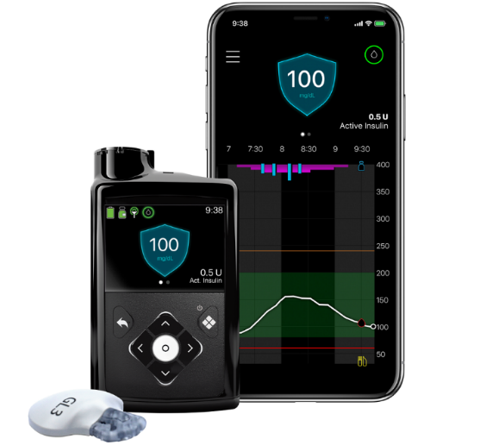
Primary Children’s Hospital Diabetes Program
Eccles Outpatient Facility
81 Mario Capecchi Drive
Salt Lake City, Utah 84113
To register call 801-662-1640

All classes start at 4:00 p.m.

January 11, 2021 King’s Peak Conference Room
February 8, 2021 King’s Peak Conference Room
March 8, 2021 King’s Peak Conference Room
April 12, 2021 King’s Peak Conference Room
May 10, 2021 King’s Peak Conference Room
June 14, 2021 King’s Peak Conference Room
July 12, 2021 King’s Peak Conference Room
August 9, 2021 King’s Peak Conference Room
September 13, 2021 Mt. Nebo Conference Room
October 11, 2021 King’s Peak Conference Room
November 8, 2021 King’s Peak Conference Room
November 15, 2021 King’s Peak Conference Room
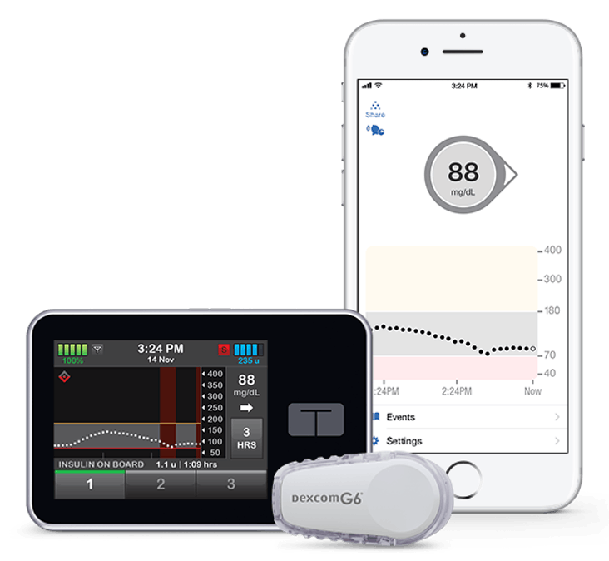
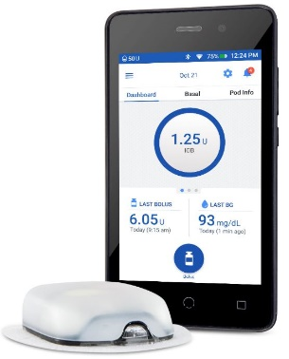

King’s Peak and Mt. Nebo Conference rooms are located on the 1st Floor

Starting an Insulin Pump Checklist

Approval from your provider- which pump do they advise?

Diagnosed for 6 months or more

A1c <10%

Test blood glucose 4 times per day or wear a Continuous Glucose Monitor

Meet with your Diabetes Provider every 6 months

Regular attendance at all other clinic appointments, per your providers’ recommendations

On at least 2 units of long-acting insulin

Attend Insulin Pump Class

Complete Food Records, the Pump Class Quiz and the Pump Waiver

REQUIRED CLASSES
Visit 1: Mechanical Training
- A 2-hour virtual training provided by pump trainers from each pump company.
- You will wear the pump with saline and will continue to give injections for a few days prior to your actual pump start with insulin.
- Be sure to call the Primary Children’s Outpatient Pharmacy at (801) 662-1680 and have them ship the saline to your home. This saline is required for your saline start.

Visit 2: Insulin Pump Start
- An in-person 2-hour pump training where insulin will be started in your pump.
- If you’re not on a Continuous Glucose Monitor, and check your blood sugar with a meter, be prepared after this training to check blood sugar before all meals, 2 hours after all meals, at bedtime and once during the night for a few weeks.
- Once you’ve started your pump, you will be required to download your pump and send this information to your pump trainer every 2-3 days and have regular phone conversations for a few weeks.

Visit 3: Pump Follow-up Visit With Provider
- An in-person pump follow-up visit with your provider, 2-3 weeks after your insulin pump start.

Visit 4: Advanced Pump Class
- A 1-hour virtual class to learn how to use the more advanced features on the pump.

