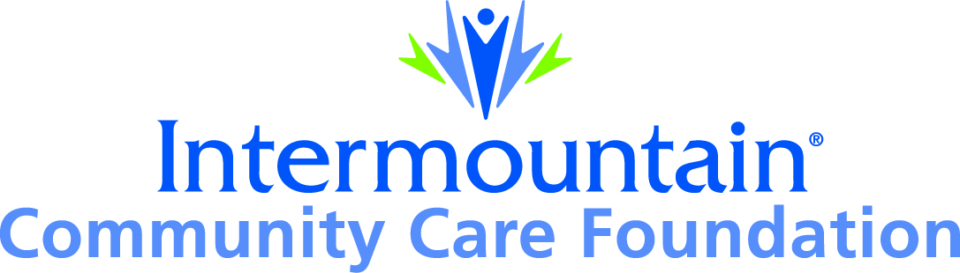  36 South State Street, 23rd Floor  Salt Lake City, UT 84111 |  | APPLICATION  Intermountain Community Care Foundation  GRANT FUNDING
Name of Organization submitting application: |  |  | Amount Requested:
Address of organization City State Zip Code

Executive Director/Contact Name: | Phone Number: | E-Mail:
Organization’s Mission Statement:

Intermountain Healthcare has established priorities for improving community health for 2017 through 2020. These priorities are identified through a regular Community Health Needs Assessment (CHNA) conducted in the Utah and southern Idaho communities served by Intermountain. The Intermountain Community Care Foundation aligns giving with Intermountain’s community health priorities.

Intermountain’s 2017-2020 community health priority is to work to prevent prediabetes, high blood pressure, depression and prescription opioid misuse through risk reduction and behavior change, screening, and treatment strategies. Programs that promote health and wellness or create access to comprehensive medical care may prevent all of these conditions and continue to be a priority of the Foundation.

In order to qualify for grant funding, your program or service must align with one or more of following health priorities: (check appropriate boxes):

Prevention of -
- Prediabetes –improve the prevention, detection, treatment and/or management of prediabetes
- High blood pressure –improve the prevention, detection, treatment and/or management of high blood pressure
- Depression –improve the prevention, detection, treatment and/or management of depression, and reduce the suicide rate
- Prescription opioid misuse –improve the prevention, detection, and treatment of prescription opioid misuse
- Access – improve access to medical care, behavioral health, or substance use treatment
- Health promotion and wellness –increase the adoption of healthy behaviors to prevent chronic disease

Step 1: ASSESSMENT OF THE NEED
Briefly describe “the need” specific to the healthcare priority above that your program or service addresses. Please provide local data to support the need that exists:

Summarize your “commitment” to meeting the above identified need, including history of how the program or service meets the need, measures of program success and sustainability, (e.g., high percentage of program participants losing weight; reduction in A1C levels) and other pertinent information regarding the program:

Step 2 – RESPONSE TO THE NEED
Describe program strategies that meet the need by providing the following:

1. Briefly outline how the existing or proposed program solution works:

2. Describe how the funds requested will be used:

3. Describe your resources, partners and collaborations outside of Intermountain Healthcare:

4. Describe partners, collaborations, or relationships you may have with any part of Intermountain Healthcare:

5. Provide a description of the barriers the program faces and how they will be resolved:

6. Describe how you have improved the existing program over time or how you plan to improve the proposed program solution:

7. Describe how your program does not duplicate services:

8. Describe how you verify income when providing services to low-income, uninsured or medically-underserved clients:

Step 3 - EVALUATION
What are the baseline measures from which you will compare the program’s outcomes?

What are the target outcomes you expect to achieve from the program over the next 12 months?

How often do you plan to measure and evaluate your outcomes over the next 12 months?

Step 4 - SUSTAINABILITY
List the top five sources and amounts from which funding of $5,000 or more has been received in the past year for the program and the organization to establish diversification of funding and program sustainability:

We can’t commit that we will always have funding, nor can we guarantee that your application will be successful in competing against others in upcoming funding cycles. With that in mind, describe how you plan to sustain the program should future funding from the Intermountain Community Care Foundation not be available to you:

In addition, include a copy of the following with this Application form:
- One-page cover letter
- Audited financial statement (current to within two calendar years of application deadline)
- Letter designating 501(c)3 status
- Itemized budget for organization
- Itemized program budget for the specific program for which you are requesting funds
- Current list of board of directors, including occupations, addresses, contact information
- Current list of staff, including names and positions

The Application form, with all the attachments listed above, must be e-mailed to iccf@imail.org by or on the deadline date. Applications that fail to meet the criteria or are otherwise incomplete, will not be considered. All decisions concerning Intermountain Community Care Foundation grants made by the Board of the Foundation will be final. Foundation grants are restricted to non-profit organizations within Intermountain’s service area of Utah and southern Idaho.
.
The organization named above is applying for consideration as a recipient of an Intermountain Community Care Foundation grant and has submitted the information required.

____________________________________ ___________________________________________ _____________________
Name of Executive Director (Print Name Here) Signature Date

